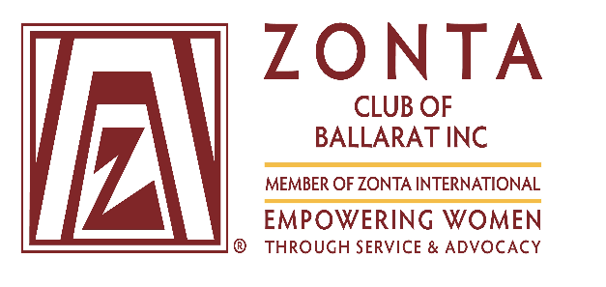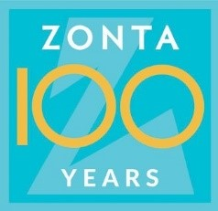

Ballarat’s Great Women 2021

Members of the Zonta Club of Ballarat invite you to join us in our quest to showcase the achievements of local woman who:
- were born, educated, or have worked in Ballarat; and
- have made a significant contribution to the local community

If you wish to nominate a local woman who meets these criteria, you may consider the following fields of endeavour: health, education, law, finance, business, trade, the arts, sport or the volunteer sector, to suggest a few.

The nomination process for the 2021 Honourees closes on Tuesday 1st December 2020, with the announcement of the finalists in February 2021.

If your Nominee is successful, we invite you to support your Honouree at a celebratory presentation event on the evening of Thursday 25th March 2021.

Nomination form

My contact details (Nominator)
Full name
Address
Town
Postcode
Phone
Mobile
Email

Contact details of the person I’m nominating (Nominee)
Full name
Address
Town
Postcode
Phone
Mobile
Email

** We suggest that you make direct contact with your Nominee to ascertain whether she agrees to have her name put forward, and to seek her assistance in completing this form.
Nomination story
Name of Nominee
A few words or a statement that captures your Nominee’s contribution
(i.e. Innovative Educator, Human Rights Campaigner, Supporter for those in need)
Where the Nominee grew up
Education and employment
Overview of the Nominee’s achievements and how
E.g.
- What positive change has she contributed to?

- What are her strengths?
What have been the great experiences in the life of the person you are nominating?
Nominator’s reason for this Nomination
(not more than 25 words)

A personal quote from the Nominee to sum up her philosophy on life
(not more than 25 words)

Additional information

The information given above will be used to prepare a 250-word statement to introduce the Honouree at the Presentation Event and be published on the website.

Signed: _________________________________________(Nominator)

Date: ____________________

Nominations to be submitted by Tuesday 1st December 2020

All nominations need to be submitted in two parts – the Nomination form and a photograph sent separately, so two files. The Nomination form can be sent as either a Word document or a pdf format, and a good quality head and shoulders photograph of 600 dpi and 10 x 15 cms in size, saved as a jpeg e.g. marysmith.jpeg file sent separately.

Nominations can be emailed to: zontaclubofballarat@gmail.com or provided in hard copy and mailed to –
Zonta Club of Ballarat
PO Box 1223
Ballarat 3350

Telephone enquiries to Val Sarah on 03 5332 4824
Website: www.zontaballarat.com

The Zonta Club of Ballarat holds the copyright to all stories submitted
and stories may be published in a number of ways that are considered appropriate by the Zonta Club of Ballarat e.g. our club newsletter
and local newspapers

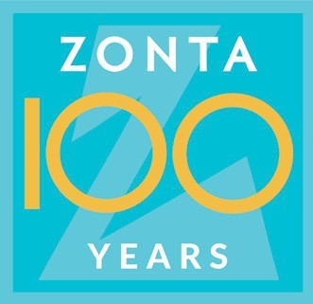

Zonta International and
Zonta International Foundation

MISSION

Zonta International is a leading global organization of professionals empowering women worldwide through service and advocacy.

VISION

Zonta International envisions a world in which women’s rights are recognized as human rights and every woman is able to achieve her full potential. In such a world, women have access to all resources and are represented in decision-making positions on an equal basis with men. In such a world, no woman lives in fear of violence.

THEME

Empowering Women Through Service and Advocacy

