Dear Student Leader, 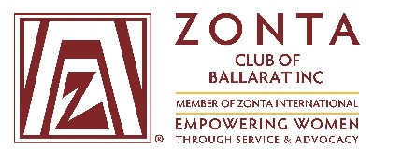
We are pleased to announce that applications are now open for the 2022/23 Young Women in Public Affairs Award (YWPA), proudly sponsored by the Zonta Club of Ballarat. The goal of Zonta International YWPA Award program is to encourage young women to participate in public affairs by recognizing a commitment to the volunteer sector by evidence of volunteer leadership achievements and a dedication to empowering women worldwide through service and advocacy.
The YWPA Award is annual event for the Zonta Club of Ballarat and our intention is to proceed with the event adjusting to COVID-Safe requirements as required.
Further details regarding the eligibility, application and assessment processes are detailed on the attached documentation. The Award winner will be eligible to represent the Zonta Club of Ballarat through the Zonta International YWPA Award
Apply to secretary@zontaballarat.com
Attached are
- 2023 YWPA application form (interactive PDF format) – available to download from the Zonta Club of Ballarat website https://www.zontaballarat.com/ywpa
- Privacy Policy and Publicity Authorization
- Application Recommendation Form
- Verification of Enrolment (to be completed by school representative)
2022/23 YWPA Award - Zonta Ballarat key dates
Applications due: 5.00 pm Friday 23 September 2022
CHANGED to Friday 30th September
Full application requirements are detailed on the application form plus completion of the Verification of Current Enrolment Form, and Application recommendation Form.
Shortlisted Interviews: Morning of Saturday 8 October 2022 Ballarat Library
Shortlisted applicants will be invited to represent their application at an interview with a representative from the Zonta Club of Ballarat, a local politician and Zonta International YWPA awardee 2020. Further details, including time of interview will be provided closer to the date.
Finalist Awards Event: Breakfast meeting, 7am Thursday 13 October 2022, Ballarat Yacht Club. At this event, finalists will be invited to provide a short 5-minute speech in support of their application. The Finalist of the 2022/23 YWPA Award will be presented with a $500 bursary to be used to further their studies. Family, friends and school guests are welcome to attend this event. Further details will be provided closer to the date.
We would be delighted if you could promote this opportunity to your senior female student group. Please feel free to contact us at the above email address if you would like further information.
Kind regards,
Caroline Nolan. President, Zonta Club of Ballarat and on behalf of the Young Women in Public Affairs Sub-Committee

