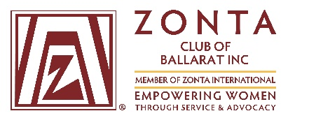

June 21, 2018

Dear Student Leader Coordinator,

Re: Zonta Club of Ballarat – Young Women in Public Affairs Award

We are pleased to announce that applications are now open for the 2018 Young Women in Public Affairs Award, proudly sponsored by the Zonta Club of Ballarat. The Young Women in Public Affairs Award is an annual event for the Zonta Club of Ballarat. The goal of Zonta International Young Women in Public Affairs Award program is to encourage young women to participate in public affairs by recognizing a commitment to the volunteer sector by evidence of volunteer leadership achievements and a dedication to empowering women worldwide through service and advocacy.

Attached are:
- 2018 application form (interactive PDF format) – available to download from our Club website www.zontaballarat.com as of 1 July 2018
- 2018 Background information and statistics
- 2018 YWPA - Ballarat poster (which you may wish to circulate to your students or display on a notice board)

YWPA Zonta Ballarat key dates:

Applications due: 5.00pm Friday 3 August 2018
Full application requirements are detailed on the application form.

Shortlisted Interviews: Saturday 11 August 2018

Finalist Dinner: Thursday 23 August 2018
Family, friends and school guests are welcome to attend this event

We would be delighted if you could promote this opportunity to your senior female student group. We will be in touch with you again early in Term 3. Please feel free to contact us at one of the email addresses below, if you would like further information.

Kind regards,

Sharelle Knight and Caroline Nolan
Zonta Club of Ballarat – Young Women in Public Affairs Sub-Committee
Sharelle.knight@bigpond.com Carolinenolan50@yahoo.com.au

